Lab 09b - Implement Azure Container Instances

Task 1: Creating a container instance along with new resource group

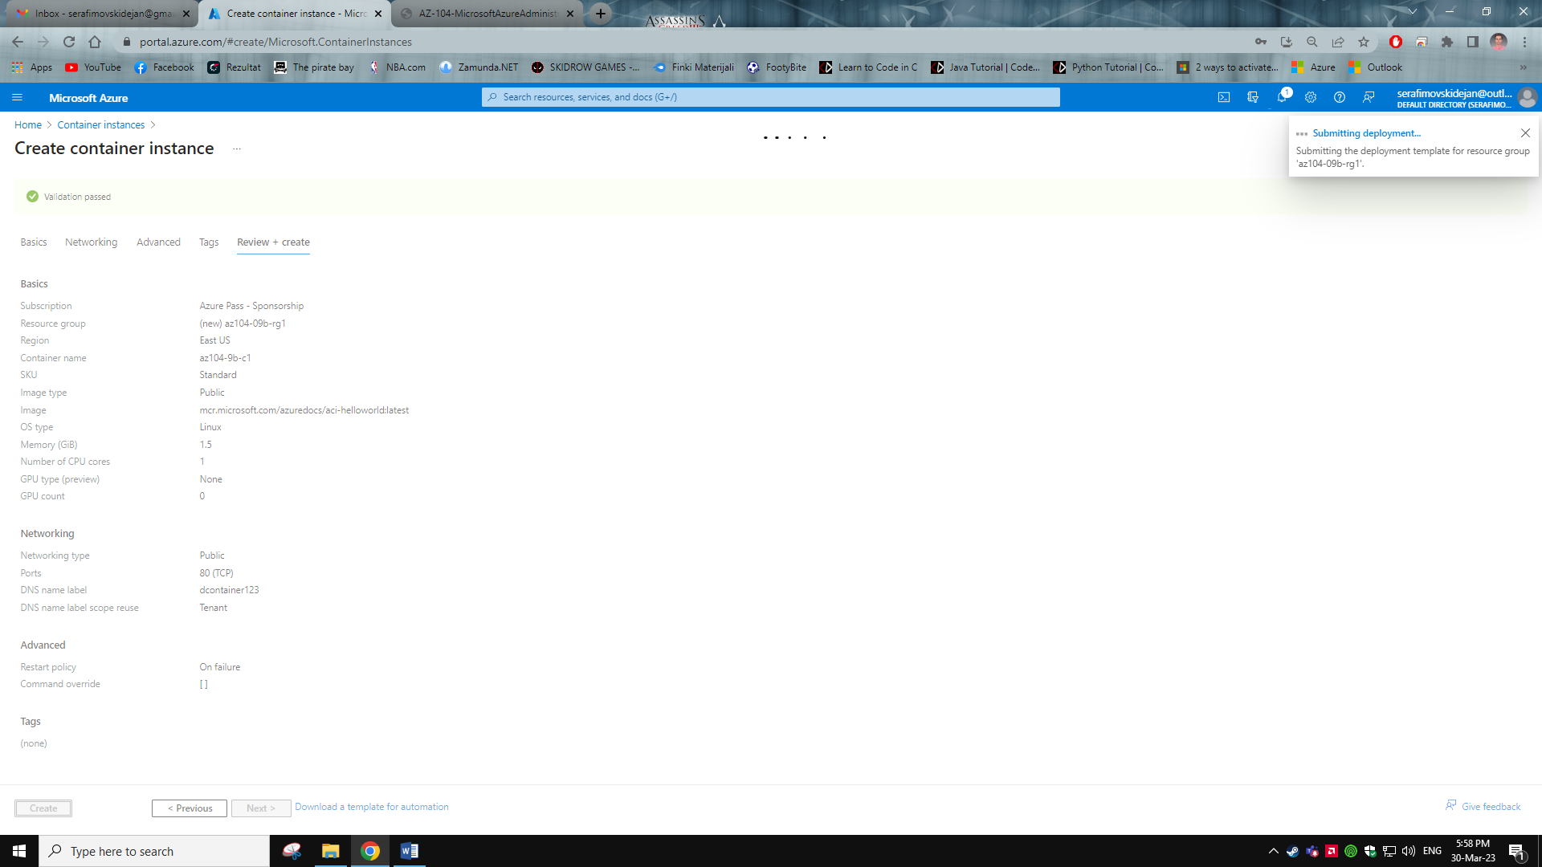

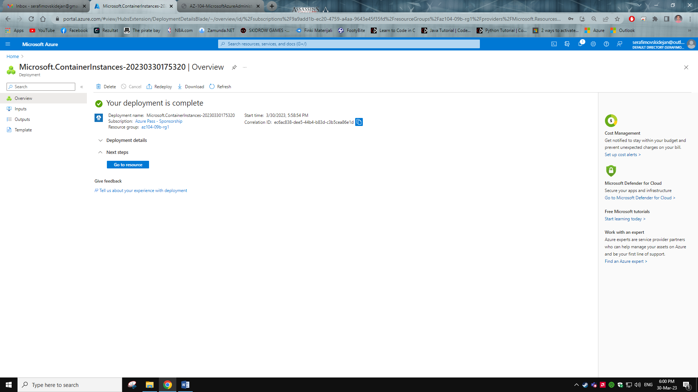

Task 2: Review of the Azure container instance

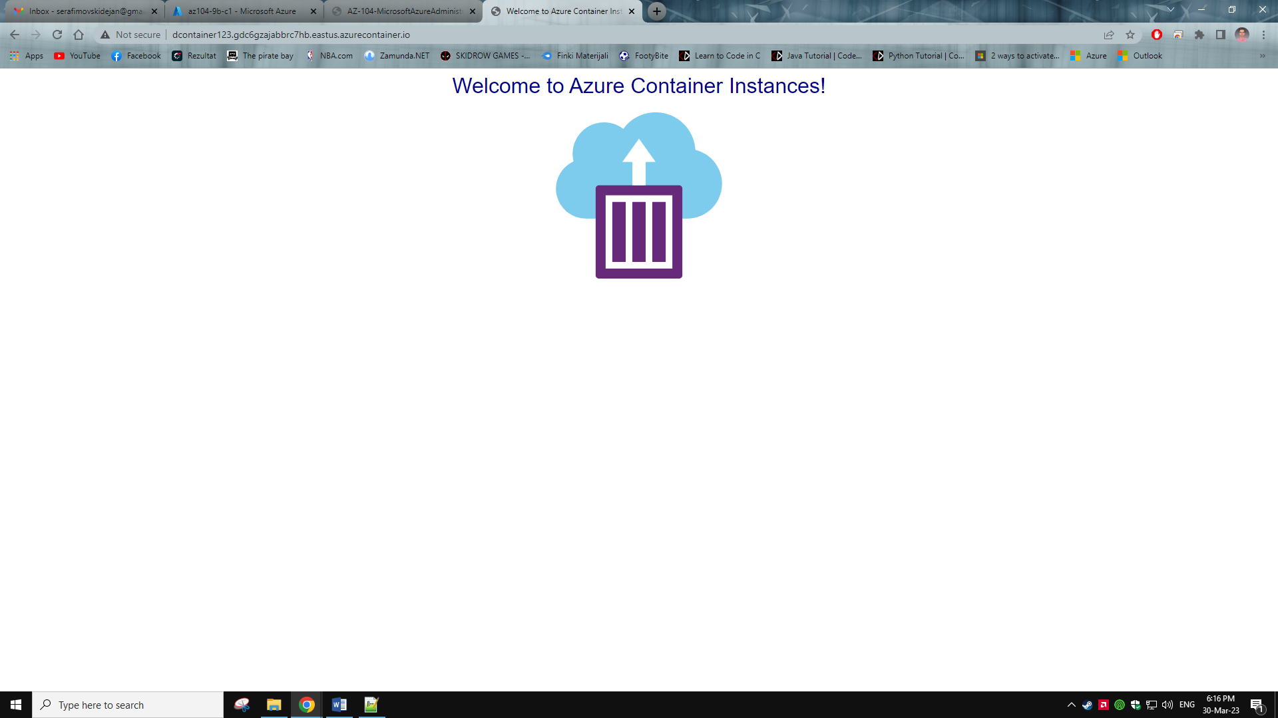

Verifying that I have HTTP GET request generated

